**Scenario 1**

As the IT administrator for a small corporate network, my supervisor has asked me to gather some networking information for the Office1 computer.

Enter **ipconfig /all** command in Microsoft’s Windows Terminal (PowerShell) to find the answers to the following questions:

1. What is the IPv4 address of the workstation?

1. What is the subnet mask?

1. What is the default gateway address?

1. What is the address of the first DNS server that the workstation will use for name resolution?

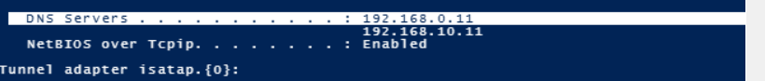

1. How did the computer get its IP configuration information?

**Scenario 2**

I am in the process of troubleshooting a networking issue and need to find the answers to several questions.

1. What is the IPv4 address of the workstation?



1. What is the subnet mask?



1. How did the computer get its IP configuration information?

**Automatic Private IP Addressing (APIPA)** because the IP Adress falls within the range: 169.254.0.1 to 169.254.255.254 which means that it does not provide internet access.

**Scenario 3**

I was asked to gather some networking information for the CorpDHCP server.

1. What is the IPv4 address of the server?



1. What is the subnet mask?



1. How did the computer get its IP configuration information?

DHCP Enabled is set to No, that means the IP address is **manually** assigned.